

 **MIDTERM EXAM FALL 2022**

 SNC2413 – Computer Communications and Networks

|  |  |  |  |
| --- | --- | --- | --- |
|  | **Duration: 20 Minutes** | **Course Instructor: Faraz Ali, Faisal Masud Sheikh, Athar Suleman** | **Total Marks: 10** |
| **Roll No: ____** | **Student Name: ______________** | **SECTION: F1, F2, F4** |

**Follow the below-given instructions**

**1.** Cutting, Over-writing is not allowed

2. Answer all questions in the context of class discussions, handouts, and the textbook.

3. Manage your time accordingly.

**-------------------------------------------------------------------------------------------------------------------------- SECTION “A” MCQ’S**

**Attempt all questions Total marks (10)**

1. A _______ is the physical path over which a message travels.
2. Path
3. Medium
4. Protocol
5. Route
6. A_________ set of rules that governs?
7. Protocols
8. Standards
9. RFCs
10. Servers
11. DSL telcos provide which of the following services?
12. Wired phone Services
13. ISP
14. Wired Phone Services and ISP
15. Network routing and ISP
16. In ______ the channel is divided into number of slots for each user to transmit data in the respective time slot
17. Time division multiplexing (TDM)
18. Frequency division multiplexing (FDM)
19. Statistical Multiplexing
20. Analog Multiplexing
21. OSI stands for __________
22. Open system interconnection
23. Operating system interface
24. Optical service implementation
25. Open-service internet

Page 1/2

P.T.O

1. TCP/IP model does not have ______ layer but the OSI model has this layer.
2. Session layer
3. Transport layer
4. Application layer
5. Network layer
6. The network entity that satisfies http requests on behalf of original web server is
7. DHCP Server
8. Proxy Server
9. DNS Server
10. None of these
11. Most packet switches use this principle ____________
12. Stop and wait
13. Store and forward
14. Store and wait
15. Stop and forward
16. To deliver a message to the correct application program running on a host, the _______ address must be consulted. of the following is an application layer service?
17. IP
18. MAC
19. PORT
20. FTP
21. Electronic mail uses which Application layer protocol?
22. SMTP
23. HTTP
24. FTP
25. SIP

Page 2/2

 **MIDTERM EXAM FALL 2022**

CSNC2413 – Computer Communications and Networks

|  |  |  |  |
| --- | --- | --- | --- |
|  | **Duration: 70 Minutes** | **Course Instructor: Faraz Ali, Faisal Masud Sheikh, Athar Suleman** | **Total Marks: 40** |
| **Roll No: ____** | **Student Name: ______________** | **SECTION: F1, F2, F4** |

**Follow the below-given instructions**

1. If you need to make assumptions, please write them**.**
2. Manage your time accordingly.
3. Only use a black or blue pen, a ball pen.
4. Read questions carefully before attempting
5. Attempt all questions on the answer sheet
6. Understanding is part of the examination, therefore no query will be entertained during the exam
7. Start with the name of your creator, Don't panic, he is always with you, Don't cheat, he is watching you

**--------------------------------------------------------------------------------------------------------------------------**

**SECTION “B” Short Questions**

**Attempt all questions Total marks ( 60 )**

1. What advantage does a circuit-switched network have over a packet-switched network?
2. Describe why an application developer might choose to run an application over UDP rather than TCP?
3. UDP and TCP use 1s complement for their checksums. Suppose you have the following three 8-bit bytes: 01010011, 01100110, 01110100. What is the 1s complement of the sum of these 8-bit bytes?

Show all work. With the 1s complement scheme, how does the receiver detect errors? Is it possible that a 1-bit error will go undetected? How about a 2-bit error?

1. In order to achieve a reliable communication, we can use Stop and Wait (SAW) protocol, Go-Back-N and Selective Repeat. You are required to explain the working of Stop and Wait (SAW). Show the working of that protocol using timing diagram.
2. Consider the scenario given below in the diagram, where transmission speed and link length are given against each link, consider propagation speed on each link is 3x108 m/sec. Assume a packet length of 1500 bits is to be transferred from host to the server. Determine end-to-end delay when a packet length of 150 bytes is to be transferred from host to the server. Also determine the throughput? Ignore processing and queuing delays.

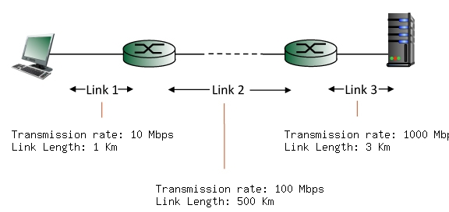

Transmission Rate: 10 Mpbs

Link Length: 5 Km

Transmission Rate: 100 Mpbs

Link Length: 10 Km

Transmission Rate: 1000 Mpbs

Link Length: 4 Km